**Admin Panel**

***Updated 26.06.2015***

1. Click on link = /support/manual=>**Fixed**

Preview smartphone screen encounters error

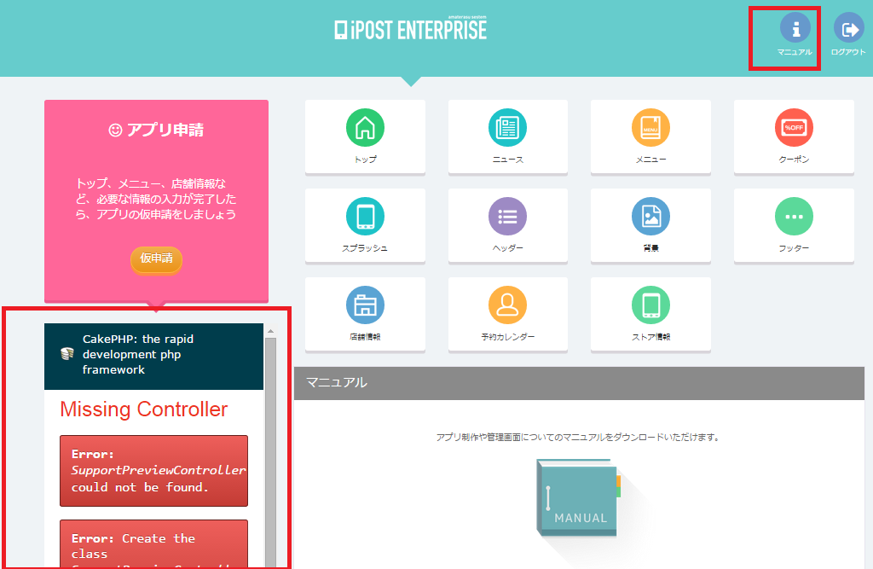

1. Click on icons, then click into “Click here” text as hightlighted in red below => encounter error =>**Fixed**

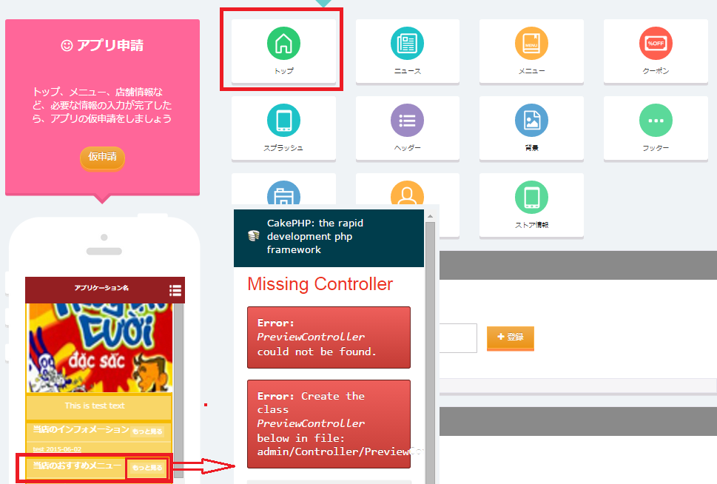

1. News&other forms=>**Fixed**

* style textbox # selectbox error

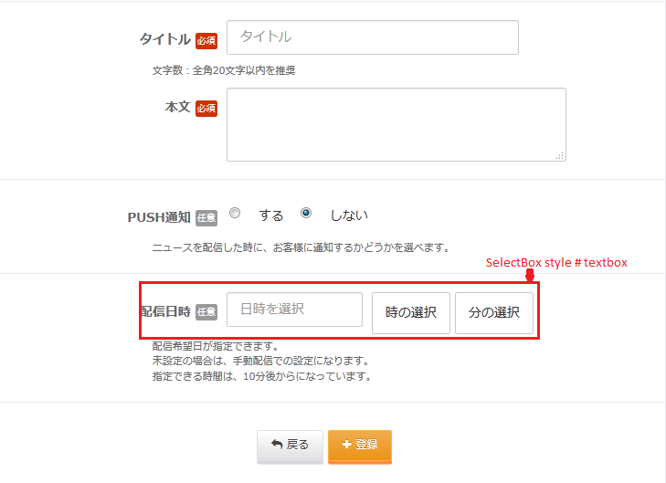

1. Menu =>**Fixed**

* Advane or button Back

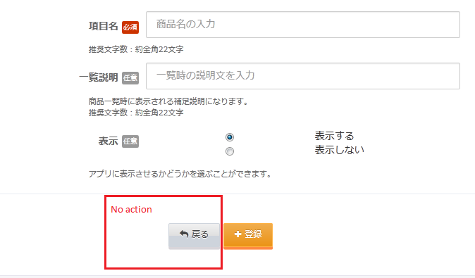

1. Splash=>**Fixed**

* Setting splash image

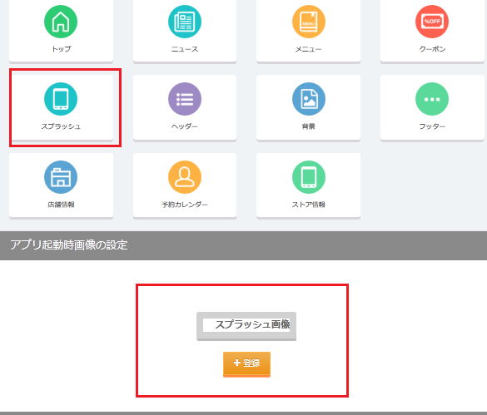

1. Background=>**Fixed**

* Can not set background image

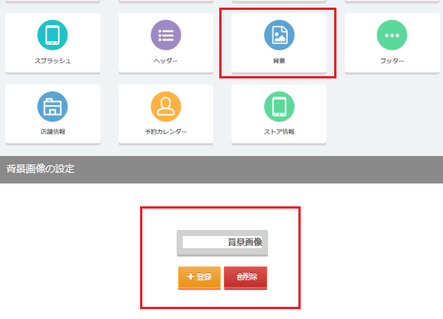

1. Footer=>**not yet Fixed?**

* When insert then currently API /**tabmenu/[CLIENT_ID]** result = [{"type":"top","icon":"0"},{"type":"top","icon":"1"},{"type":"news","icon":"3"},{"type":"news","icon":"16"},{"type":"news","icon":"14"}]

**API => Fixed**

But must correct as below = [{"type":"top","icon":"A"},{"type":"top","icon":"C"},{"type":"news","icon":"D"},{"type":"news","icon":"E"},{"type":"news","icon":"F"}]

Admin => **working?**

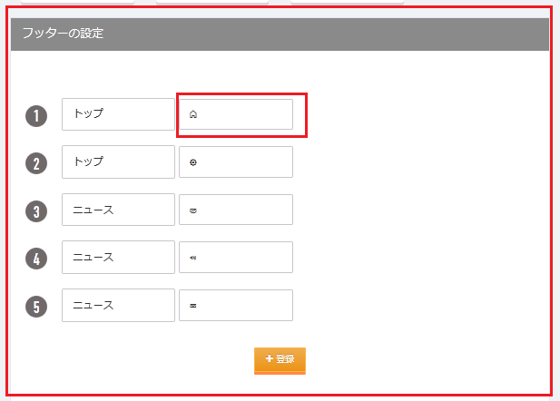

1. Shop profile=>**Fixed**

* Edit shop image errors

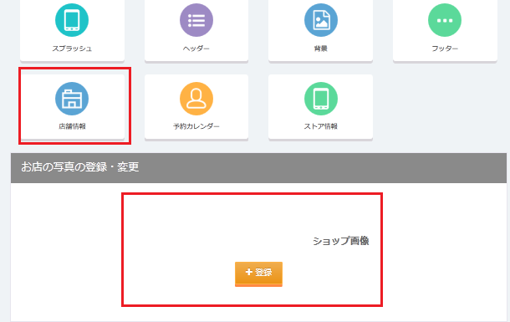

1. SideMenu=> **Fixed**

* Disappear side menu management in admin panel?

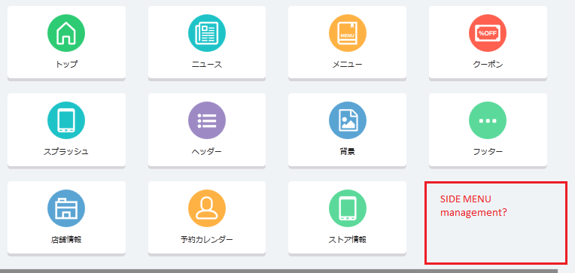

1. News
2. Create news – Do not validate this form?=>**fixed**

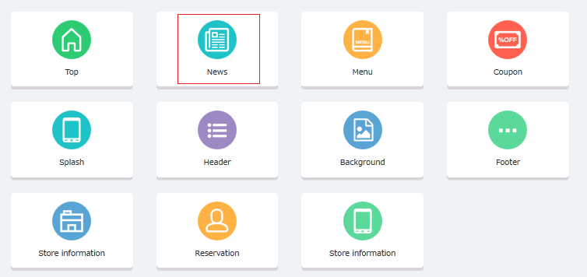

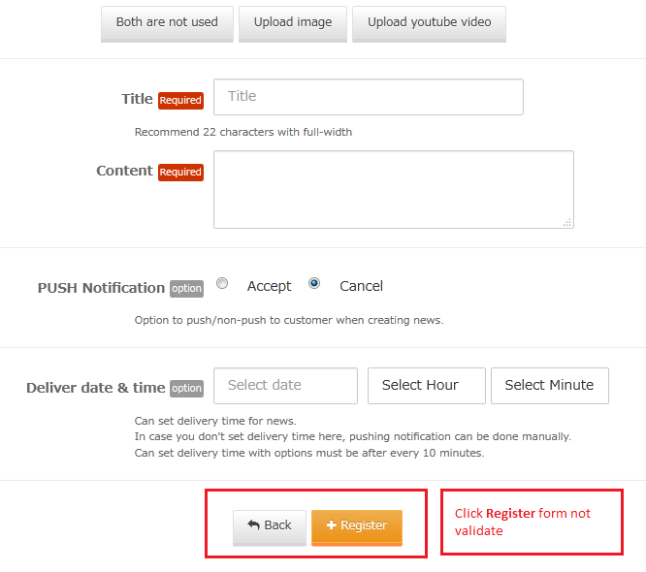

1. Edit News – Image disappears after edit?=>**not yet fixed?**

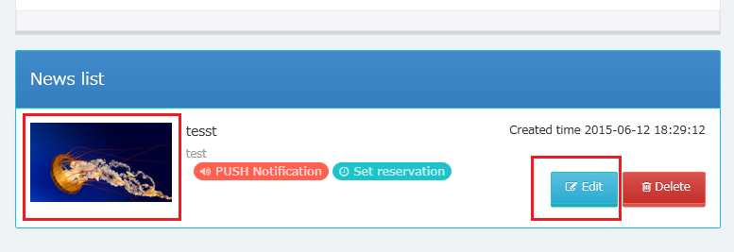

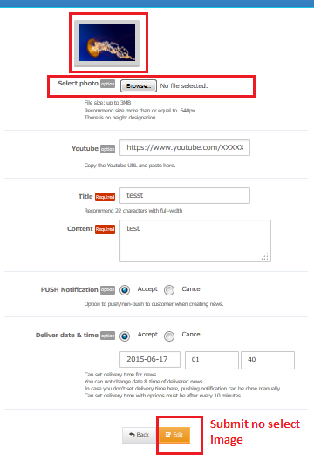

1. Create new News: Deliver date & time, Created, Modifed: is empty =>**new bug**

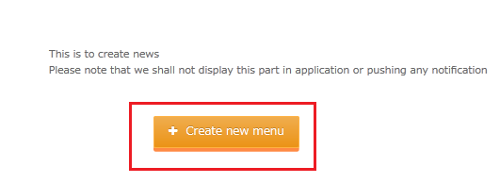

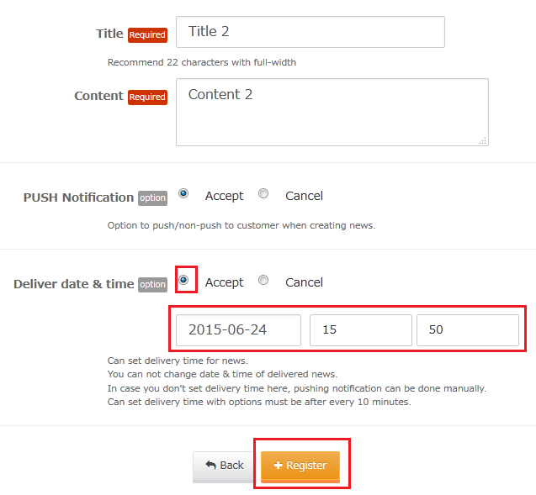

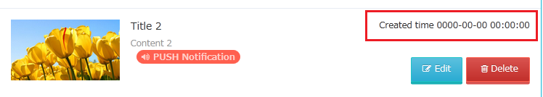

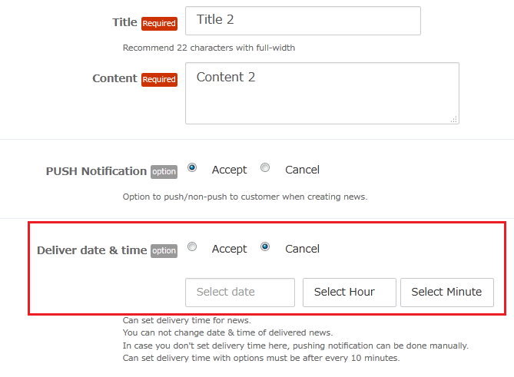





1. Menu=>**not yet Fixed?**

* Add Item do not validate any form?

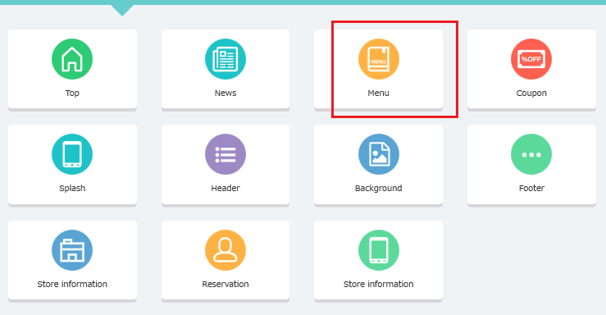

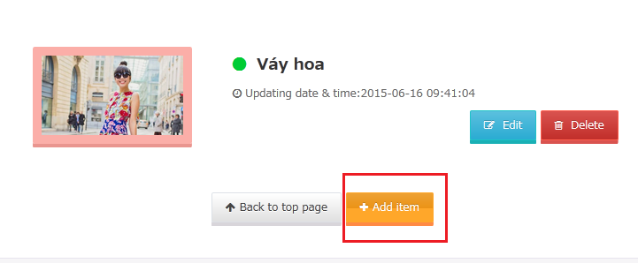

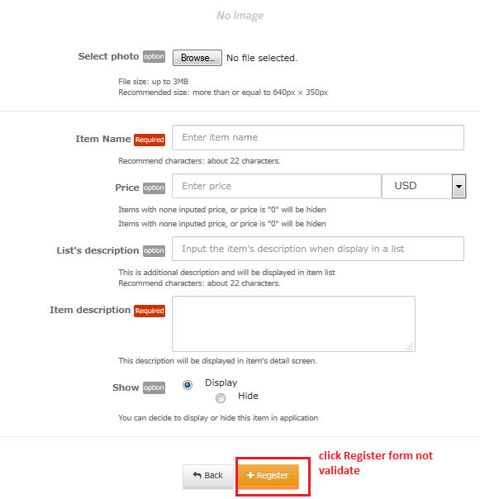

1. Block =>**not yet Fixed?**

* Click Register => No action?

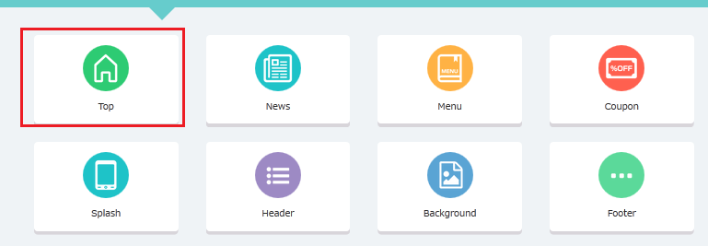

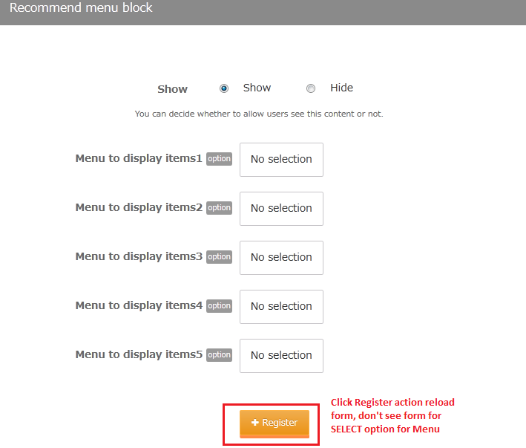

1. TOP

* Differentwith old Version: do not allow to configure in Admin panel? =>not yet fixed?

Reproduce steps:

+ Admin panel: Input menu data similar to an coupon

+ Mobile view: menu not display the same as coupon???

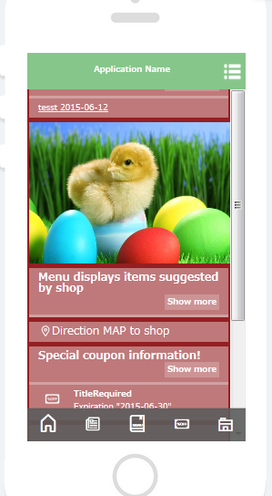

1. TOP => click to area “coupon” =>new bug

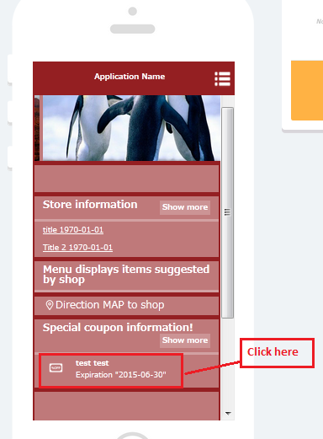

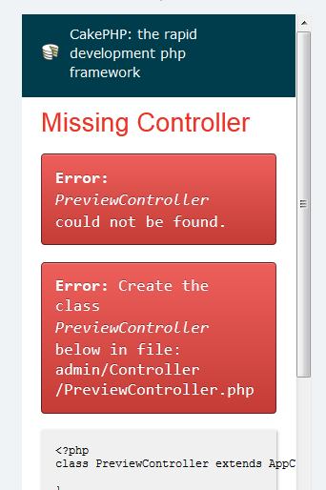

1. Can you please check for us: old version is different with current version as below:

Old version:

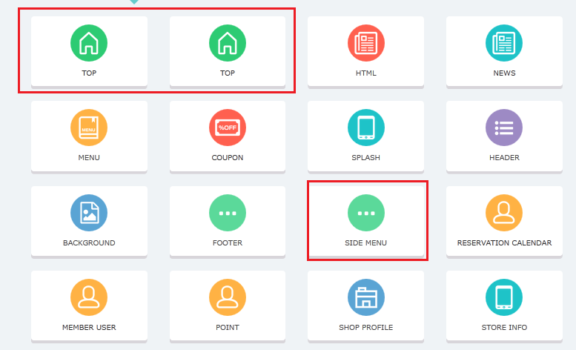

Current version:

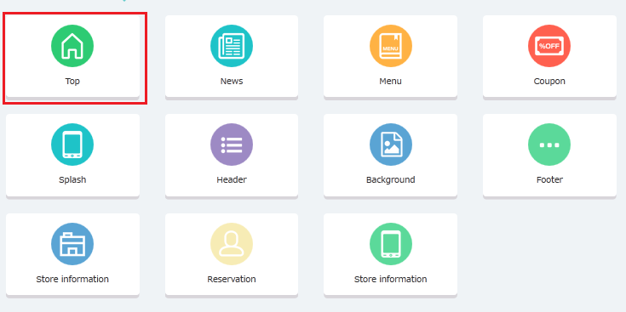

1. Reserve => **new bug**

* Calendar does not show button Prev, Next and Saturday date?

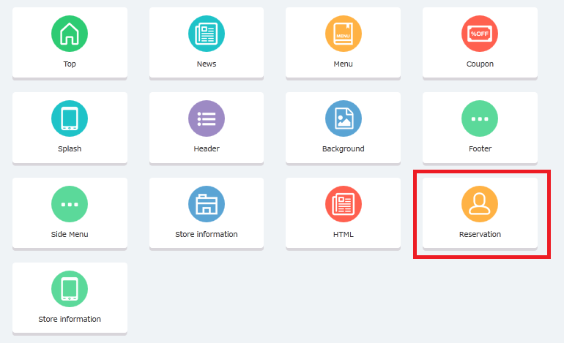

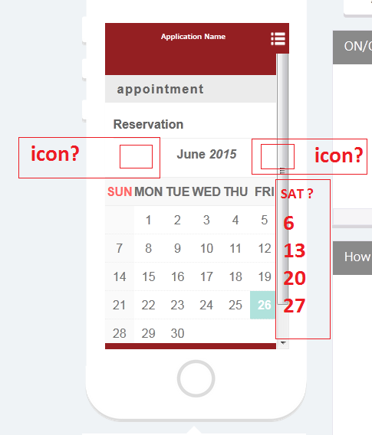

**API**

1. API TOP : /top/[client_id]

* API TOP is different with old version?

1. API TABEMENU: /tabmenu/[client_id]=> **Fixed**

* Missing sidemenu management in Admin panel => Could not test this API